# DAC Platform Open VPN Access

Version 1.0

Revision History

|  |  |  |  |  |
| --- | --- | --- | --- | --- |
| Version | Date | Author | Approver | Reason |
| 1.0 | 27/02/2018 | Chetna Sharma | Indu Neelakandan | Draft |
|  |  |  |  |  |
|  |  |  |  |  |
|  |  |  |  |  |
|  |  |  |  |  |
|  |  |  |  |  |

DAC OpenVPN 2.0 Setup

To connect to the Platform 2.0, OpenVPN must be installed and setup correctly on user's machine. OpenVPN provides an encrypted network connection between the Platform and User's machine.

**Before you can use OpenVPN, you need to make sure that you have local admin right to your Desktop or Laptop.**

Once you have local admin right to your Desktop or laptop, follow the following steps.

## Installing OpenVPN

1. Install OpenVPN 2.3.8-I601 and TAP-Windows 9.21.2
2. After installing both files copy the config files (DAC-Internal.ovpn and DAC-External.ovpn) from the appendix to c:\Program Files\OpenVPN\config\ (if file already existed, replace it)

## Setting-up google authenticator

1. Go to apple appstore or google playstore and download “google authenticator”
2. Once downloaded, click on the + sign on “google authenticator” then select "Manual Entry"
3. In Account, enter "AD 2.0 UserID" (to be provided by SM team)
4. In key, enter "google authenticator code" and save. (Code will be provided by SM team)

## Logging into OpenVPN

1. Right click on OpenVPN icon on your desktop then select run as administrator
2. 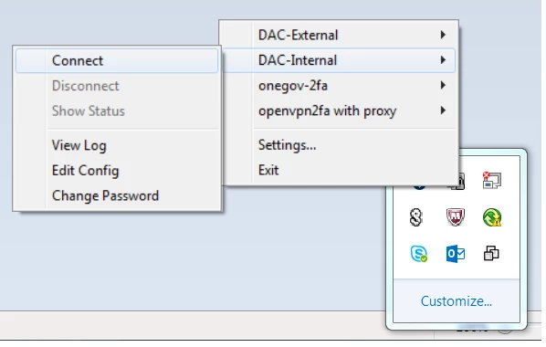A small icon will appear in the right bottom corner of your screen then select the appropriate config file and connect
3. Enter your username and password as requested then click OK, the screen should disappeared by itself if it accepted your login.

**Username:**         AD 2.0 UserID

**Password:**          Your_AD_PasswordXXXXXXX   (XXXXXXX – this is the code generated from google authenticator)

External Access to the DAC Platform

1. Logon to your home network or mobile phone hotspot from your laptop
2. You will see following screen when you are connected.

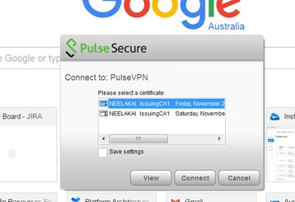**Please don’t click on any button here. Let it be!**

1. Go to logon screen by pressing Control + Alt + Delete
2. Click Start Task Manager
3. High light *Connect to: Pulse VPN*.

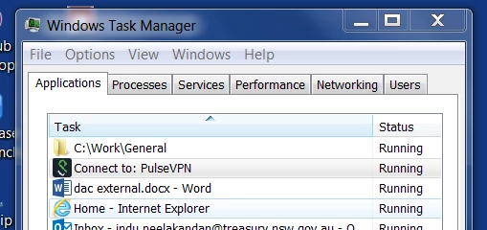

1. 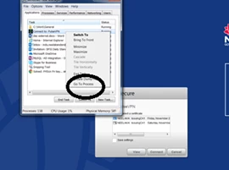Right click and select Go To Process
2. 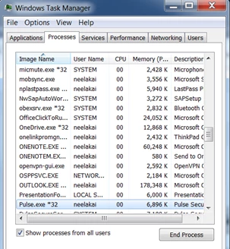Click End process
3. 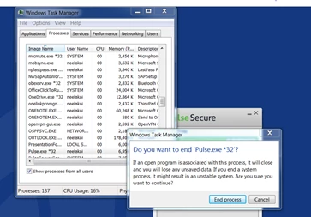Click End Process again
4. Start OpenVPN as **administrator**
5. Ensure DAC external config file (DAC-External.ovpn) is same as the one in the Appendix

* Right click on lock icon
* 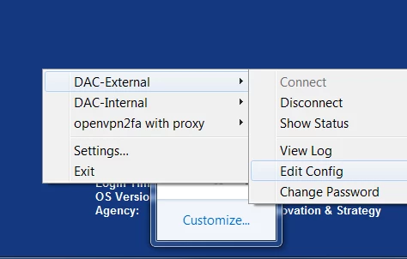Click Edit Config to check DAC external config file

1. Right Click on the lock icon
2. Select DAC-External

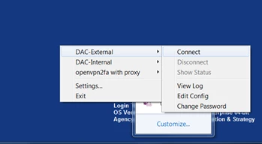

1. Enter your username and password as requested then click OK, the screen should disappear by itself if it accepted your login.

**Username:**         first name initial and surname  (eg rangus)

**Password:**         nicedayXXXXXXXXX         (XXXXXXX – this is the code generated from **Google authenticator**)

Appendix

